1. Introduction

Contents

1. Introduction 1

2. Course Preview 1

3. Life Without jQuery 2

4. Using jQuery 4

5. Value of jQuery 5

6.Developer Tools 5

6. Summary 6

# 1. Introduction

=>slides: Pg. 1

 Building modern interactive websites can be a lot of fun and even more satisfying when you stay productive by leveraging a rock solid library like jQuery. In this course, you'll learn what you need to get started with jQuery, as well as walk away with the foundation that you need to continue your learning with other courses. As a first step, let's begin with a short preview of what's to come in jQuery

# Course Preview

=>slides: Pg. 2

In this course, you'll learn about the code and concepts that you need to use jQuery effectively.

=>slides: Pg. 3

We'll start off by taking a look at the venerated Hello World code example and then move on to some more detailed examples.

=>slides: Pg. 4

Sitting in the context of a real‑world page, most of the examples are run right against this page for Coded Homes. It's a fictitious real estate site.

=>slides: Pg. 5

Using this example will interact with the page in a lot of different ways, giving you a chance to see jQuery in action in a real‑world context. Everything you need to master the content in this course is available at your fingertips. As you can see on this page, the Content tab shows how the page renders in the browser.

=>slides: Pg. 6

The HTML tab exposes the HTML just for the Coded Homes example. As this page uses Bootstrap, most of the styling for the page is taken care of by the Bootstrap framework.

=>slides: Pg. 7

But custom styles for the examples are all available behind the CSS tab as well.While you may hear me mention it at times, understanding Bootstrap is not a prerequisite for this course.

=>slides: Pg. 8

Then there's the JavaScript tab. Here you have all the code examples used throughout the entire course, and you'll see much more of these examples soon.

=>slides: Pg. 9

Finally, the Resources page includes all the detail about jQuery that you need to get started.

=>slides: Pg. 10

So with this course, I take you step by step from the very beginning and take you to a position of not only mastering the examples found in this course, but also placing you in a position of being able to continue your learning by helping you establish a solid understanding of the basics of jQuery. So as you can tell, I'm excited about jQuery. But to get a sense of its value, let's take a look at what development might look like without jQuery.

# Life Without jQuery

=>slides: Pg. 11

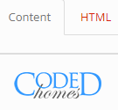

Now as you're about to see, one of the most significant benefits to working with jQuery is its ability to find and manipulate parts of a page.



So let's start off by taking a look at the street address, so 15509 Main Street. If we go over to the HTML tab, you'll see all of the markup that's used in order to create this sample page. So as we scroll down, you'll notice that here is an h2 element.



It has a class of expanded added to it, and then there's the text of the h2. So if we go back over to the address here



and inspect the element and we take off expanded, you'll notice how the characters go closer together because we're setting the letter spacing to 2.5 px. So what would the JavaScript look like for us to add a class and remove a class to that element just using basic raw JavaScript? Well, let's take a look at that. 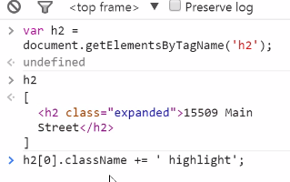

The first thing that we'll need to do is access that h2 element on the page. Now since this returns an array of all the elements on the page that it found, we need to use that array in order to make changes to the properties of a specific element. So what we'll do here is use the zero index to get into this item in the array. So here you have h2 index of 0, and then what we'll do is concatenate on the highlight class to className on that element.

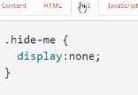

If we go over and take a look at the CSS that's applied to this page, you'll see that the highlight class sets background‑color to a yellow color. And I'm using plus equals here because, if you recall, that expanded class is already applied to the h2, and I want to make sure I keep that and not just override it by setting a value to className. So let's evaluate this statement. And so now you'll see that the className is set to expanded in highlight. So when we take a look at the content itself, you can see that the element has both of the classes applied to it, so it's highlighted in yellow here. Now that wasn't so bad to add a class to the element. But what would it look like if we want to remove just the highlight class? So to remove the highlight class, what we'll want to do is get a reference to all of the classes that are applied to an element, remove the specific one that we want, and then take that array and join it back up so that only the class that we want is applied to that element.

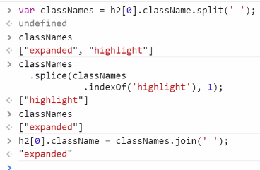  
So let's start first by getting a list of all the class names. So here you can see the classNames array has expanded and highlight in it, and it got those values because I called split by passing in a space against the className to that element. So now what we need to do is remove from the array the one that we don't want. The call to splice just returns the item that you're removing. So classNames only has expanded in that list, and so now what we need to do is join up the list and set it equal to the className of the element. And so I'm doing just that. I'm joining classNames on space. There's no space, so now className is set to just expanded.

  
 And you'll notice here that the highlight is now taken off that item. Now that was quite a bit of work just to add and remove some classes to an element. But in jQuery, this gets ridiculously simple.

# Using jQuery

=>slides: Pg. 12

Now you've just had an opportunity to see what it looks like to add and remove a class from an element using straight JavaScript. So now what I'd like to do is show you how much easier it is to do it with jQuery.

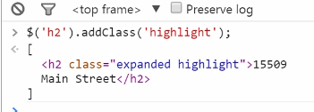

So the first thing we'll do is start off with a selector. So what I'm looking at here is I want to narrow down to the h2 on the page. And then what I'd like to do is add the class of highlight. So here I'm calling addClass, and I'll pass in the name of the class, which is highlight. And once I execute this statement, you'll notice that the element is now highlighted. Now that was pretty easy.

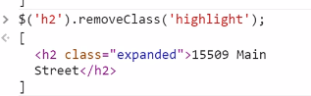  
If we want to remove the class, all we need to do is change this call to removeClass. And as I execute removeClass, that class is now gone from the element. So this barely scratches the surface, but does give you a glimpse of the value of using jQuery in your web applications.

# Value of jQuery

=>slides: Pg. 13

More than just having the huge benefits of having a simple and expressive API to work with the DOM, like you just saw in the last two demos, jQuery's origin emerges from the context of the browser wars of the late 1990s. Beyond just making the DOM easy to work with, jQuery set out to be a layer on top of web browsers of the day. This layer is meant to work around any known issues of browsers that didn't behave correctly.

=>slides: Pg. 14-15

Some might say that browser inconsistencies are much less of an issue in the era of modern web development, but that's simply not true. When you visit the link shown on this slide, you're taken to the latest version of the official document, which maintains a description of all the current jQuery browser bug workarounds.

=>slides: Pg. 16

So when the jQuery team says you use it to write less and do more, well, they mean it.

# 6.Developer Tools

Now as I introduced to you earlier in the course, this is the sample application that I've written that accompanies this course. And all this really is is a web page that's running within Google Chrome. I just have it set up to go full screen. So I can take it out of full screen, and you can see here that it's just a standard web page. And most of the code that I'll be writing will be done here within the Developer Tools window. And this is just the console of the developer tools. So usually by pressing F12 or Ctrl+Shift+I, you can open and close the developer tools. And by using this button over here, you can decide if you want to add the bottom or if you want to orient it to the side of the page. So I keep it at full screen just because it looks nicer and it's less UI clutter for you as you're watching the course. And I like to use the console because as I type the code and execute it, it's immediately applied to the page. So don't be fooled as we're going along, it's just a web page running in a browser using the developer tools.

# Summary

=>slides: Pg. 17

In summary, you've learned about the easy and expressive API found in jQuery, and you also learned about how jQuery is an abstraction layer on top of many different browsers, and you saw how to use the code and samples available in this course. In the next module, the fun really begins as you learn about the anatomy of a jQuery command. Let's get to it.

*******************************************************************************************************************************